# **Modeling of Telecommunication CDRs to identify network usage pattern**

# **Capstone Project 1 - Milestone Report**

## **PROBLEM STATEMENT**

The exponential increase in the use of internet services and mobile phones is generating large amount of data that can be used to provide useful insights about the network usage pattern.

Call Detail Record [CDR] describes a specific instance of a telecommunication transaction that passes through a network element. Every time a user performs a telecom activity such as send/receive SMS and calls, a CDR is generated. It contains information about the caller/sender ID, location, time, data used, etc. Millions and millions of such records are generated and is mainly used for billing purposes by the telecom company.

Analysis and modeling of this time series data helps to identify geographical boundaries of various usage patterns. This helps in decision making of resource allocation by telecommunication companies who own the network elements, inspecting quantitatively different aspects of human behavior such as socio-economic status of geographical regions and people's mobility. CDRs collected for a span of time can also be used in forecasting future volumes for a network.

## **DATASET**

This dataset is a part of Telecom Italia Big Data Challenge which is an aggregation of telecommunications, weather, news, social networks and electricity data from the city of Milan and the Province of Trentino. This dataset has been released to the research teams under the Open Database License (ODbL) and is maintained by Harvard Dataverse.

For this project we will use telecommunication data from the city of Milan, Italy. It is available as .txt files with tab-delimited values (TSV) from the link,  <https://doi.org/10.7910/DVN/EGZHFV>.

There are 62 files consisting of CDRs collected from Nov 1,2013 to Jan 1, 2014, one file for each day.

File size: ~ 200MB – 300MB with ~4 million rows each file

Files: sms-call-internet-mi-2013-11-01.txt to sms-call-internet-mi-2014-01-01.txt

There are 8 columns, with no headers. Each column represents,

* Grid id: identification string of a given square of Milan GRID. The geographical region of the city is spatially divided into 1000 square grids.
* Time Interval: start interval time expressed in milliseconds. The end interval time can be obtained by adding 600,000 milliseconds (10 min) to this value;
* SMS-in activity: activity proportional to the amount of received SMSs inside a given Square id and during a given Time interval. The SMSs are sent from the nation identified by the Country code;
* SMS-out activity: activity proportional to the amount of sent SMSs inside a given Square id during a given Time interval. The SMSs are received in the nation identified by the Country code;
* Call-in activity: activity proportional to the amount of received calls inside the Square id during a given Time interval. The calls are issued from the nation identified by the Country code;
* Call-out activity: activity proportional to the amount of issued calls inside a given Square id during a given Time interval. The calls are received in the nation identified by the Country code;
* Internet traffic activity: number of CDRs generated inside a given Square id during a given Time interval. The Internet traffic is initiated from the nation identified by the Country code;
* Country code: the phone country code of the nation.

As the original bundle of dataset comes from various companies (telecommunications, weather, news, social networks and electricity) with different standards, in order to ease the comparisons of different geographical areas, the city of Milan’s spatial distribution is aggregated in a grid with square cells. The area is composed of a grid overlay of 10,000 squares with size of about 235×235 meters. This dataset provides the geographical reference of each square which composes the grids in the reference system: WGS 84—EPSG:4326. It is downloaded from the link, <https://doi.org/10.7910/DVN/QJWLFU>.

File type: geojson

File size: 3MB

File: milano-grid.geojson

Columns:

* *square id*: identification string of a given square of the Milan GRID;
* *Time Interval*: The cell geometry expressed as geoJSON and projected in WGS84 (EPSG:4326).

## **DATA WRANGLING**

### **Reading data into Pandas Dataframe**

Reading 20GB of data from 62 files iteratively and merging them into a single dataframe takes about 30 min and utilizes very high system memory. Alternatively, reading a file into a dataframe, perform operations like sampling [daily, hourly], grouping & indexing that reduces the number of rows and combining these individual data frames into a single dataframe results in a faster and efficient loading operation.

### **Time Interval column**

Time Interval column is represented in milliseconds, as epoch/Unix timestamps. It is the number of milliseconds passed since 00:00:00 UTC Thursday, 1 January 1970. This column values are converted to pandas Datetime object that can be used with Pandas in built functions. This value is stored in a new column, startTime.

### **Dropping unwanted columns**

Time Interval column now has redundant values and Country code column will not be used in this project. They are both dropped from the data frame.

## **Resampling, Grouping & Indexing**

Several rows of data, with 10 min time interval are aggregated into daily (24 hour) and hourly time intervals. They are grouped and indexed by Grid ID & startTime columns. Total volume of each activity over the 2 months for individual grids is calculated.

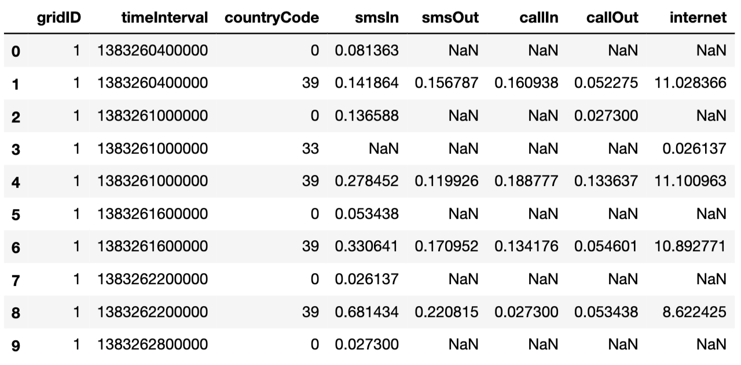

*Fig 1: Data as read from the files*

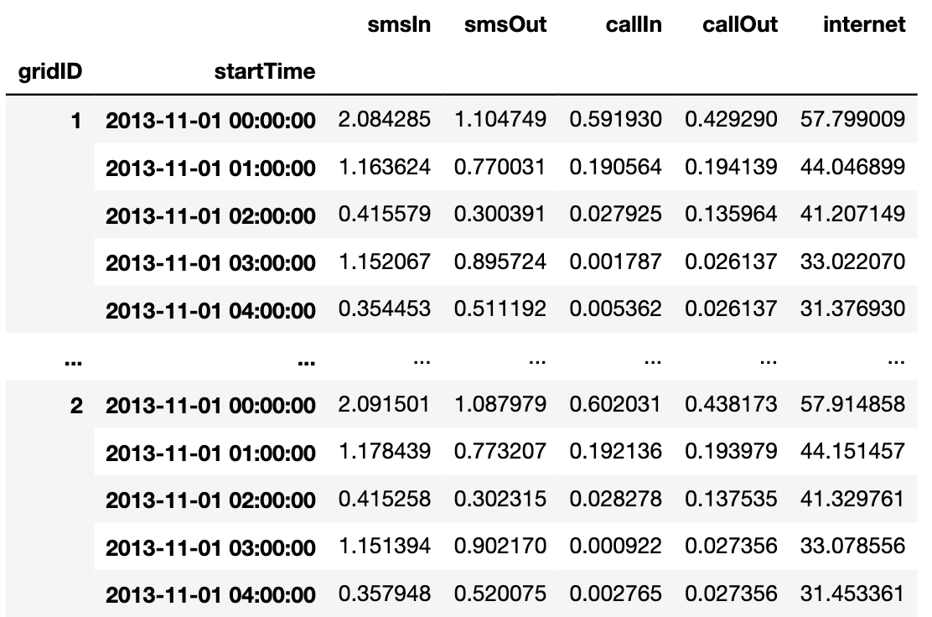

*Fig 2: Grid-wise hourly aggregation of telecommunication activities*

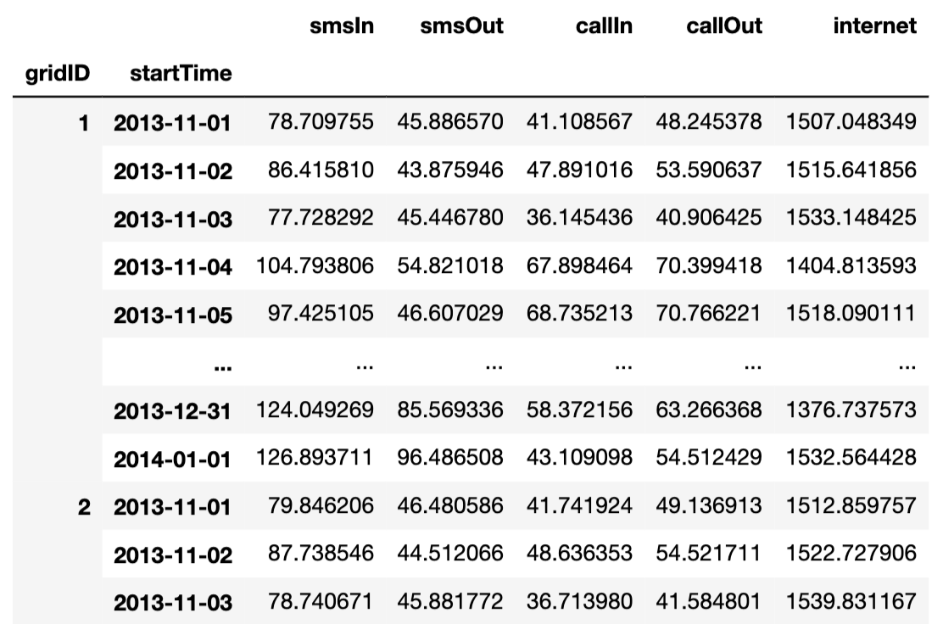

*Fig 3: Grid-wise daily aggregation of telecommunication activities*

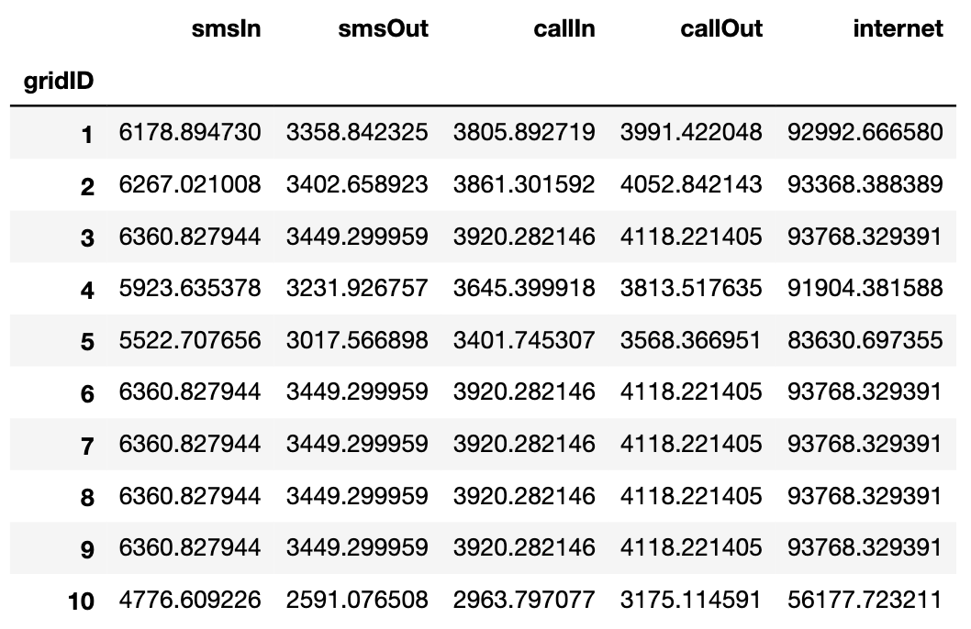

*Fig 4: Grid-wise total volume of telecommunication activities over the 2 months*

## **Visualization of Grids**

milano-grid.geojson file is loaded using packages geopandas & geojsonio that shows the overlay of 10000 grids over the city of Milan’s map.

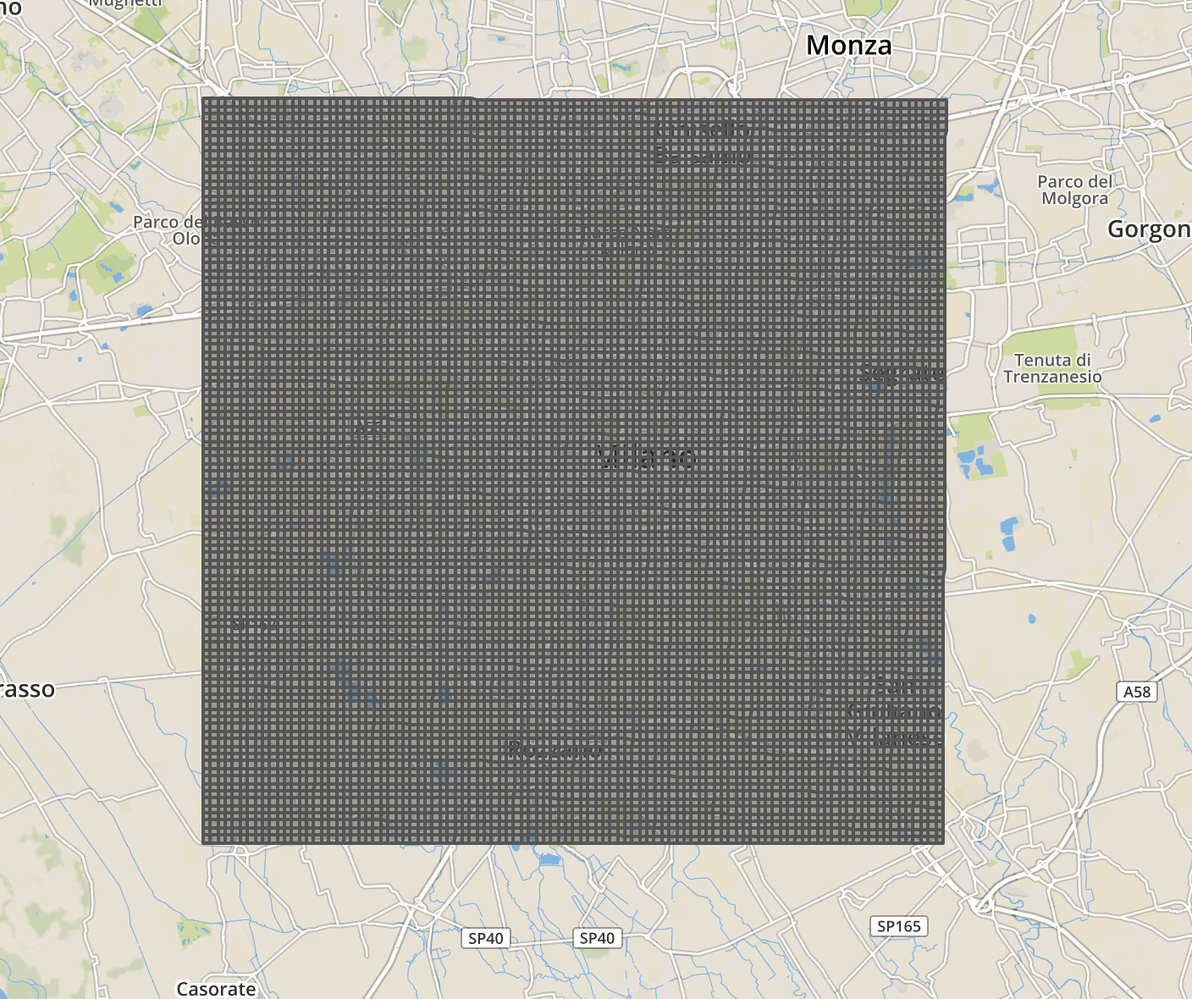

*Fig 5: Spatial aggregation of 10,000 grids over the city of Milan*

## EXPLORATORY DATA ANALYSIS

In the network, SMS-In and SMS-Out utilizes the control channel, Call-In and Call-Out utilizes transmitted over voice channel and the internet is transmitted over broadband frequencies. Thus, we will use SMS (sum of SMS-In & SMS-Out), Call (sum of Call-In & Call-Out) and Internet activity for the analysis.

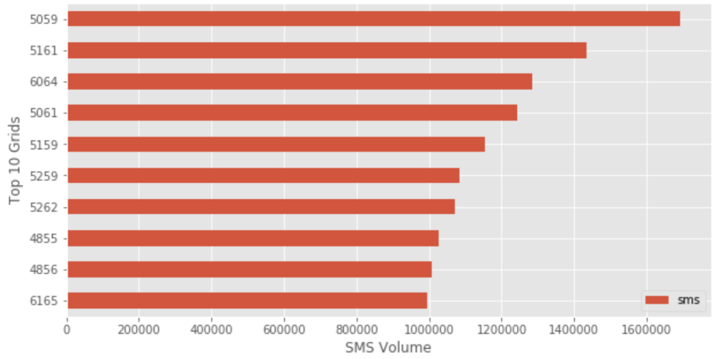

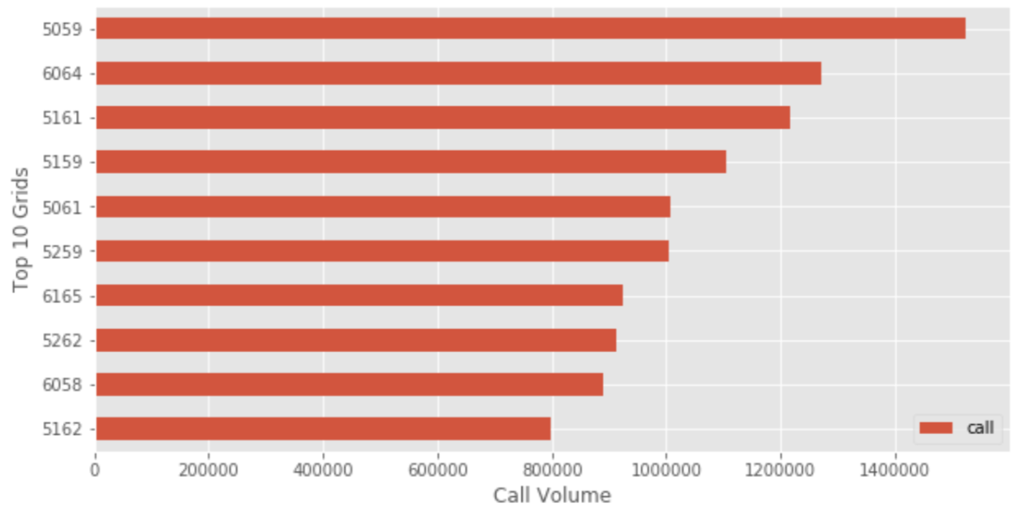

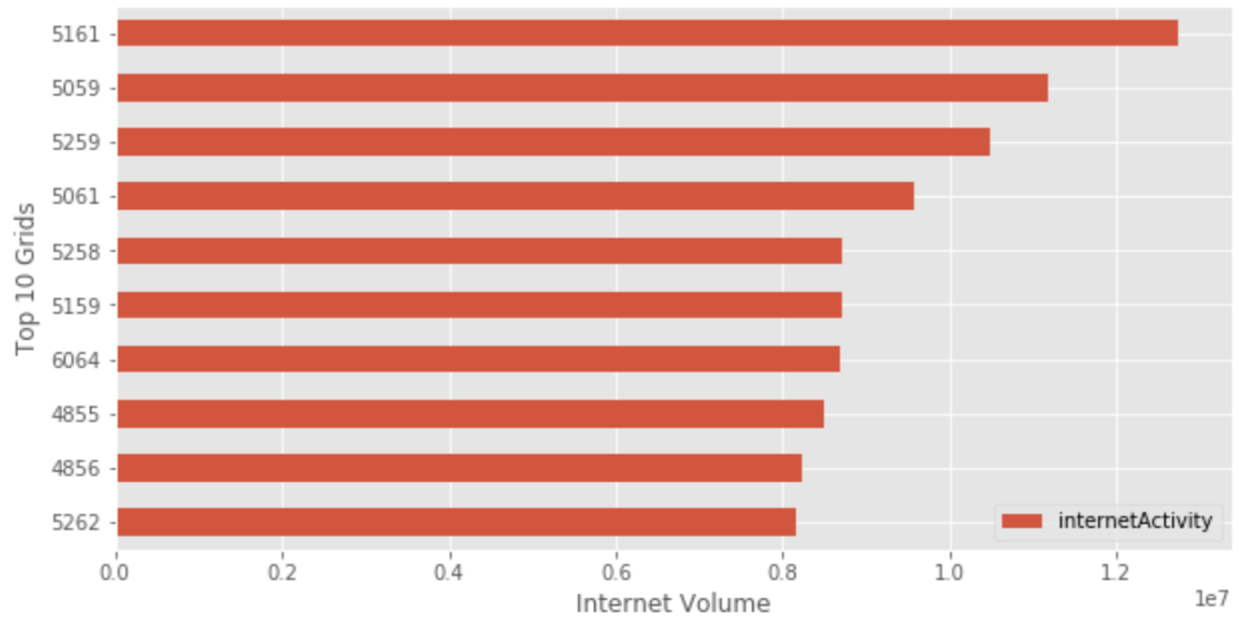

*Fig 6: Horizontal bar plots showing top 10 grids with high total volumes in each telecommunication activity*

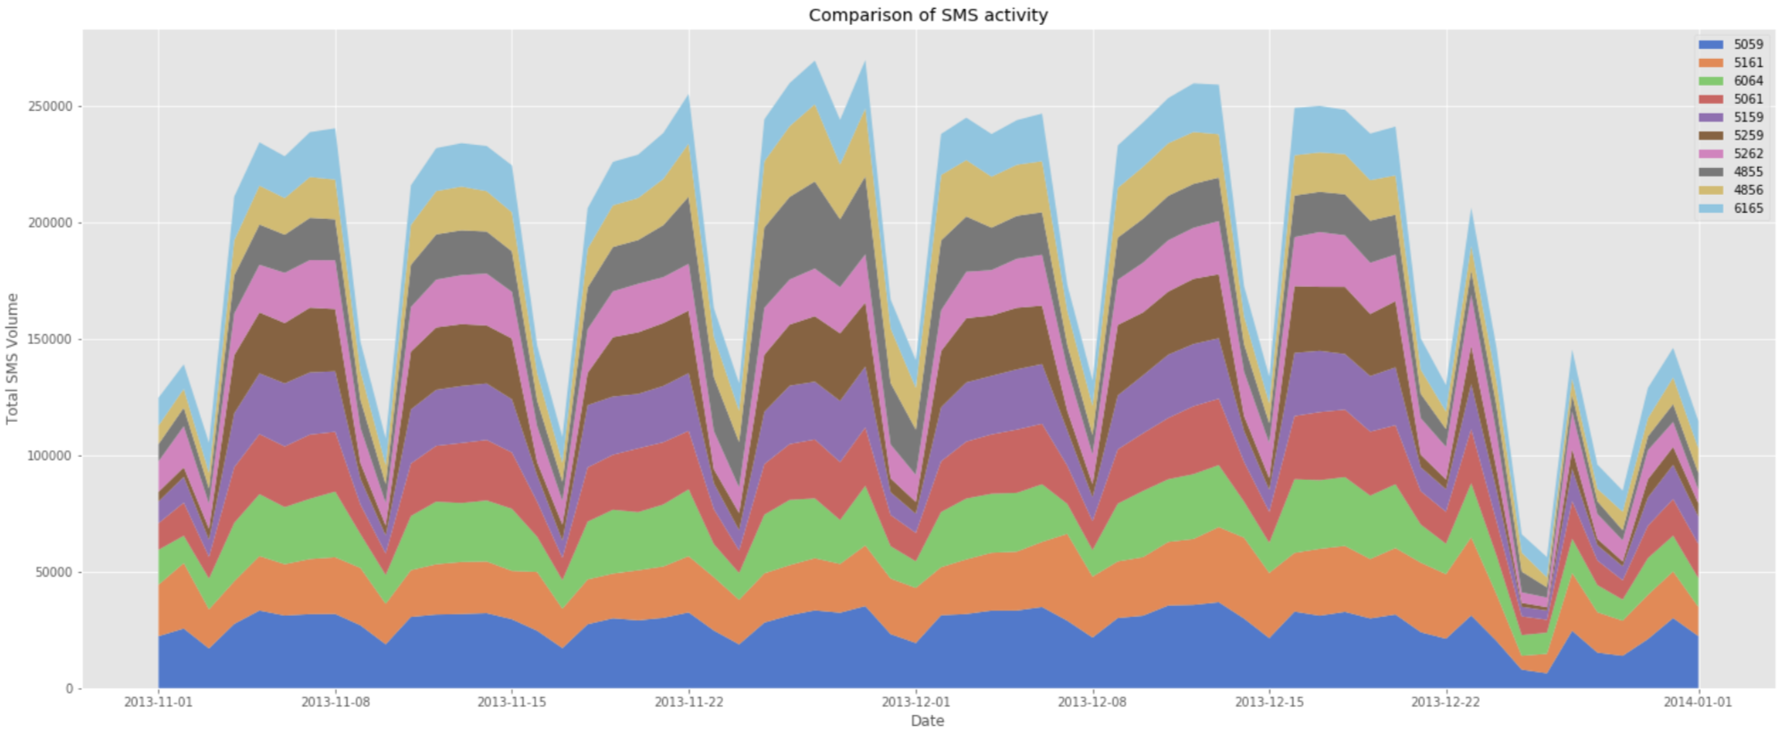

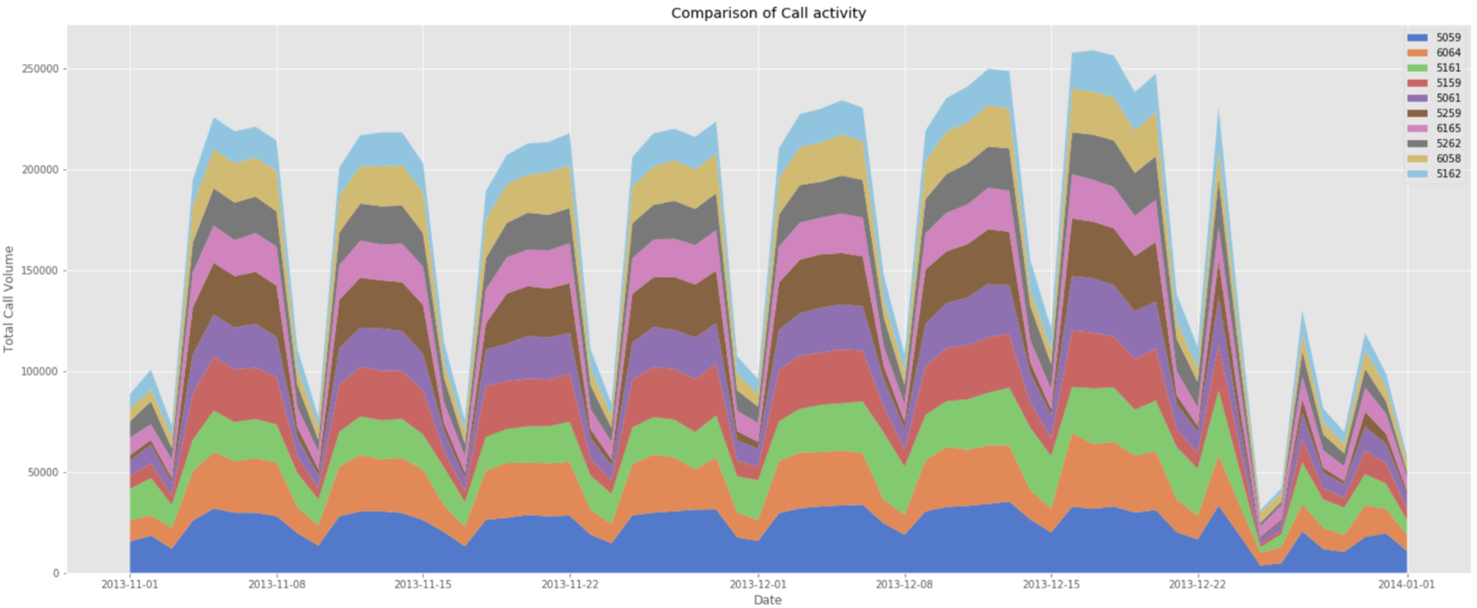

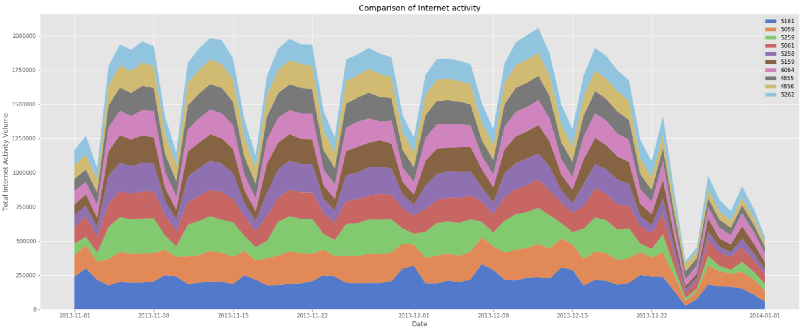

*Fig 7: Stacked area plots showing comparison of top 10 grids daily pattern*

Top 10 grids that experience high volumes for each of these activities for the 2 months are identified. From the above plots, we see that the top four grids have highly varying total volume and rest of the grids have almost same total volume for each activity. This is further verified by performing a set of one-way ANOVA tests as shown in Fig 7. P-value < 0.05 indicates mean values of the grids are not equal, P-value > 0.05 indicates means values of the grids are equal.

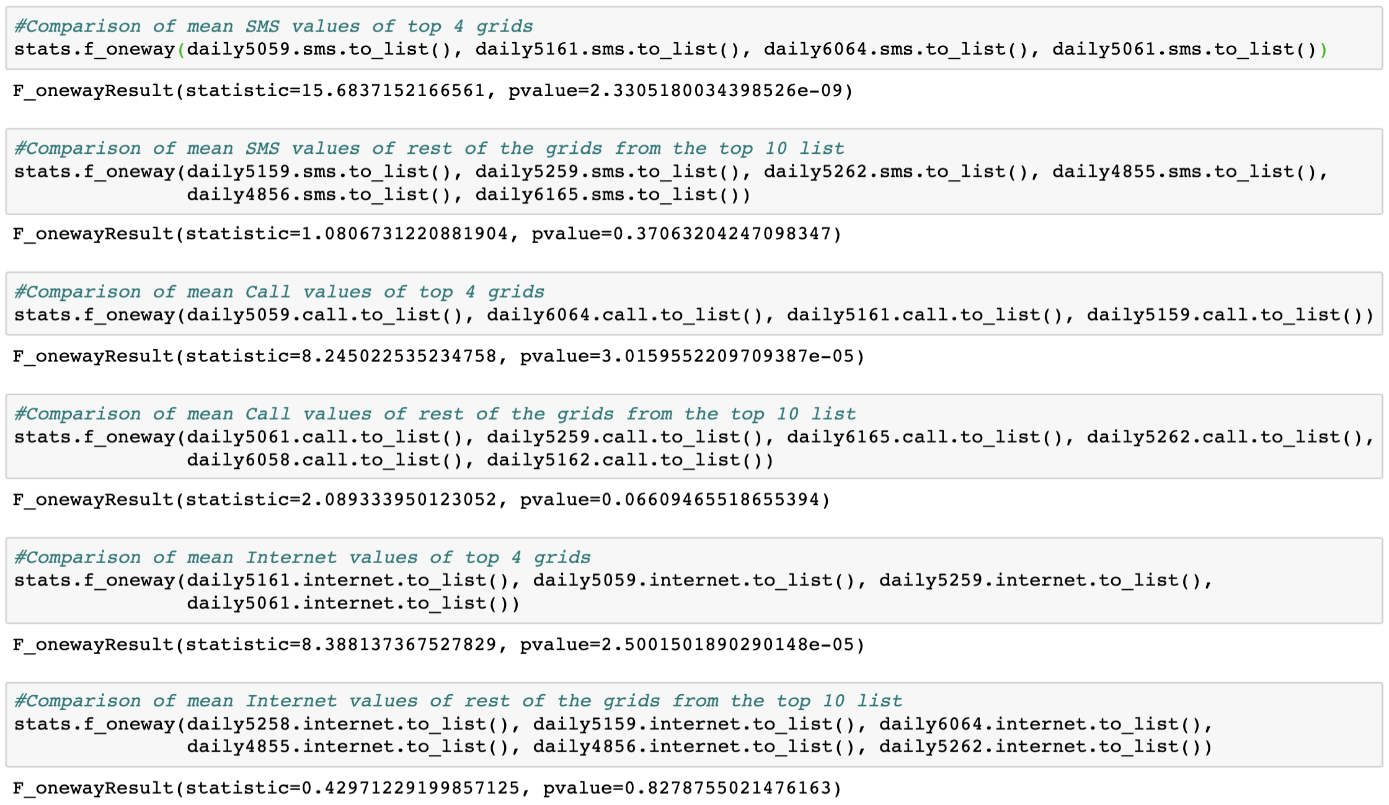

*Fig 8: One-Way ANOVA tests verifying that, except the top 4 grids, rest have similar mean volumes*

Location of these grids in the map shows that they are all from Duomo & Milano Centrale region.

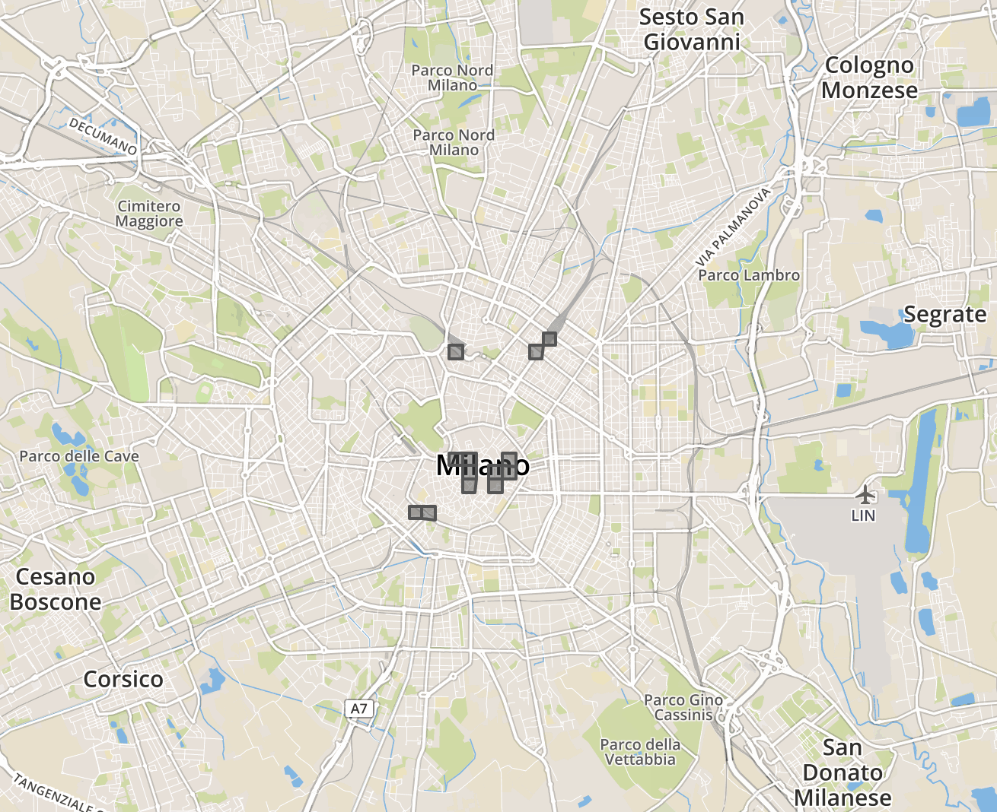

*Fig 9: Location of top 10 high-volume grids in the city map*

### **In Detail Analysis of grids from different sectors**

All the top contributing grids are from the city’s center and mostly near transport hubs, they are expected to show similar behavior and most of these grids have approximately same mean values. In order to capture variations in the city’s telecommunication activities, we will examine the following four grids that has markedly different behavioral signatures,

4259 - Bocconi, one of the most famous Universities in Milan

4456 - Navigli district, one of the most famous nightlife places in Milan

5059 - Duomo, the city center of Milan

5346 - Fiera, residential neighborhood of Milan

#### Daily Activity Plots:

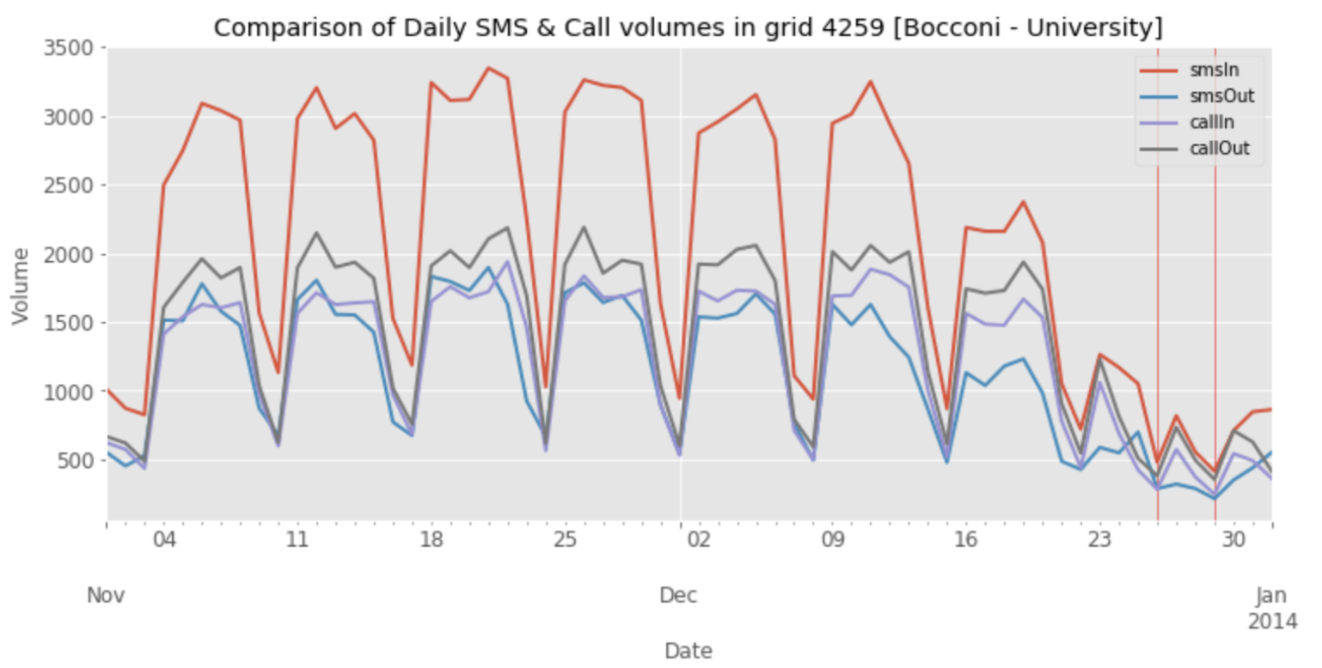

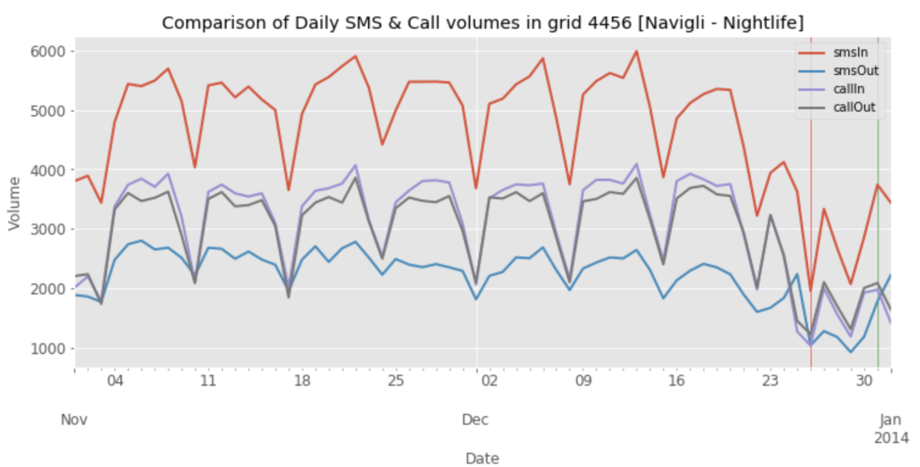

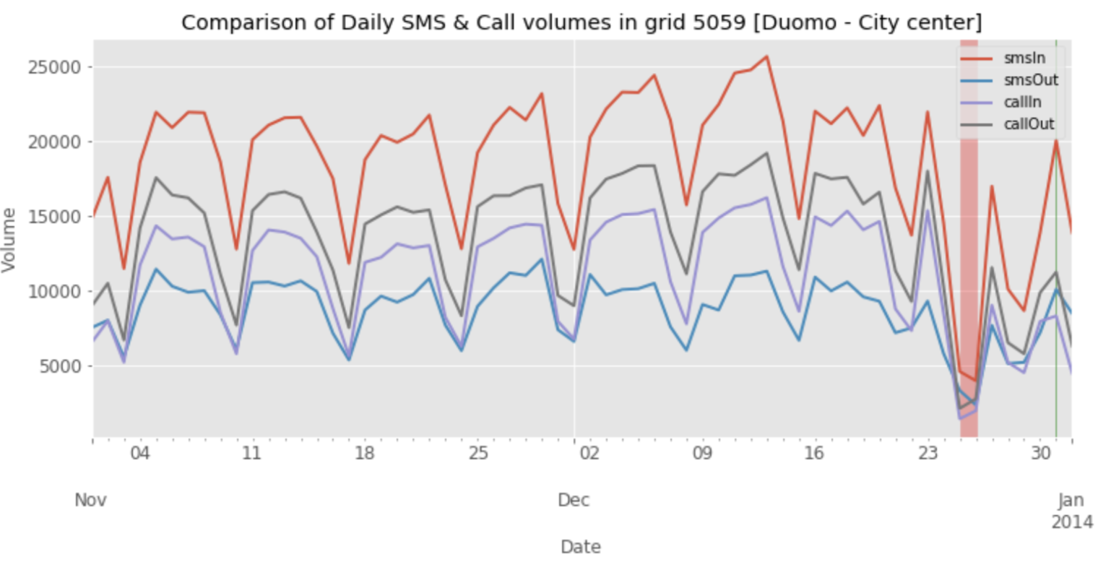

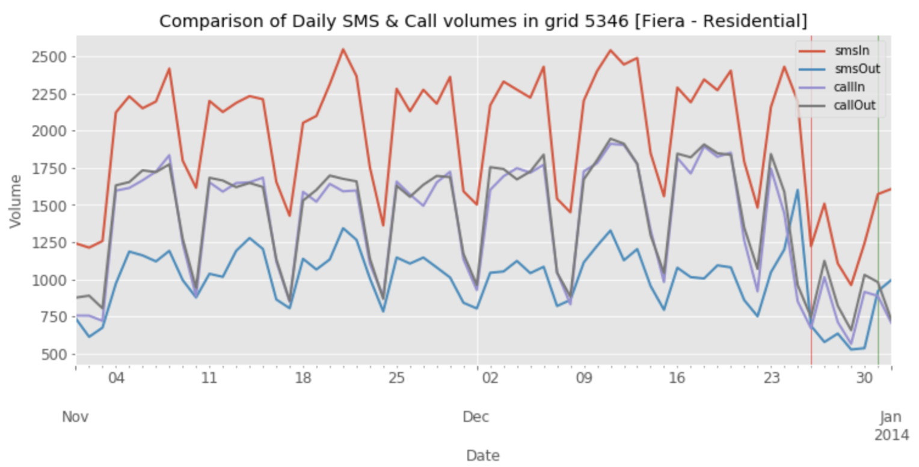

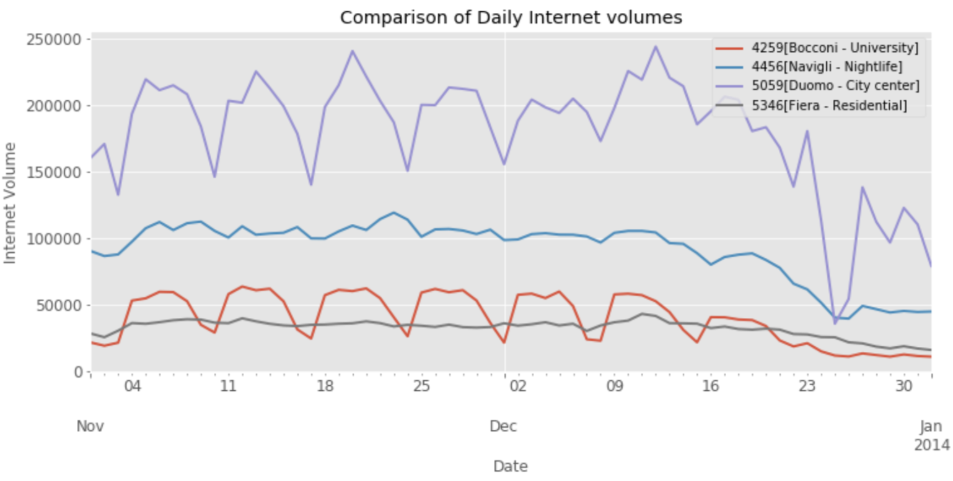

*Fig 10: Time-series plot of daily telecommunication activities of the four grids*

* **All four grids have received high volumes of incoming SMS compared to other activities.**

**Outgoing SMS has the least volume, almost equal amounts of Calls are made and received.**

* **Duomo has highest volume of all activities, followed by Navigli, then Bocconi and Fiera in the end. We can order the grids based on total volumes as,**

**Duomo [city center] > Navigli [nightlife] > Bocconi [university] > Fiera [residential]**

* **All four grids exhibit seasonality in SMS & Call activities. In internet activity Navigli & Fiera doesn’t show any seasonality. This may because of IoT, with many devices always being connected to the network.**
* **There is a drop in the volumes towards December end in all the plots [holiday season].**

#### Hourly Activity Plots:

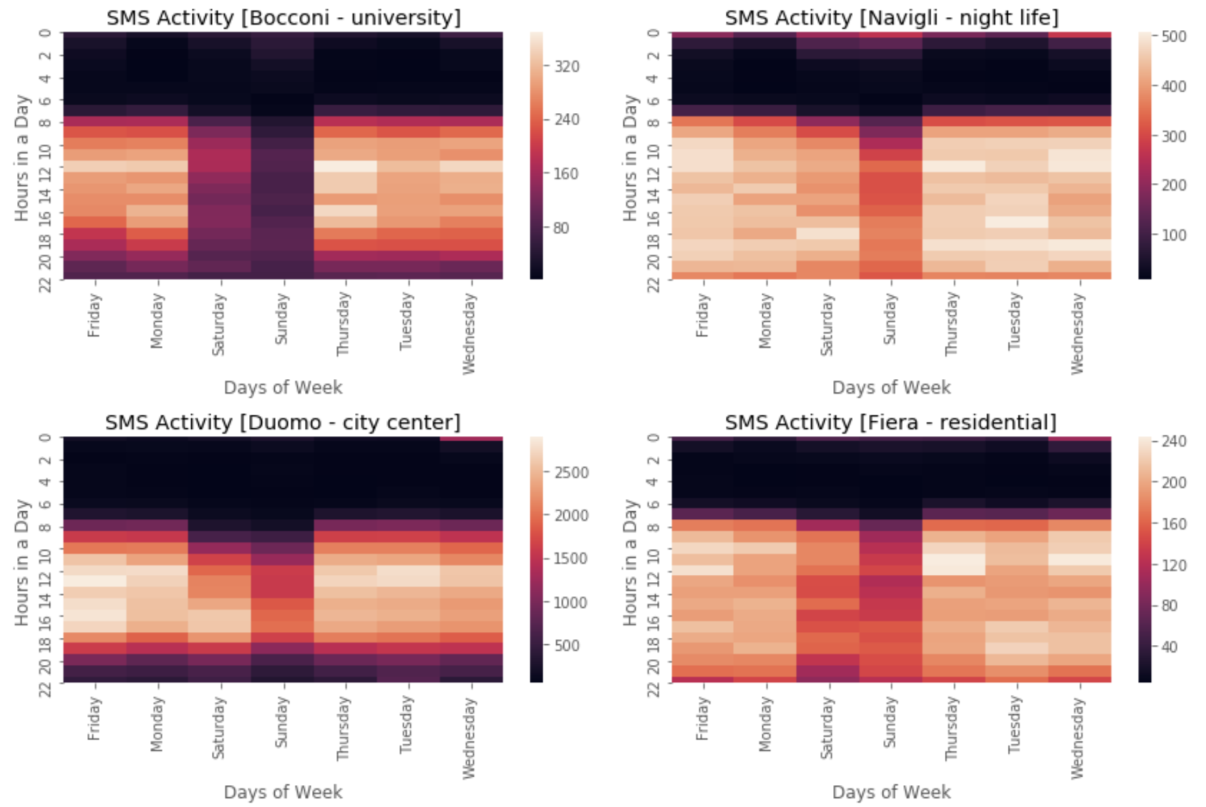

*Fig 11: Heat map of hourly SMS activity of the four grids*

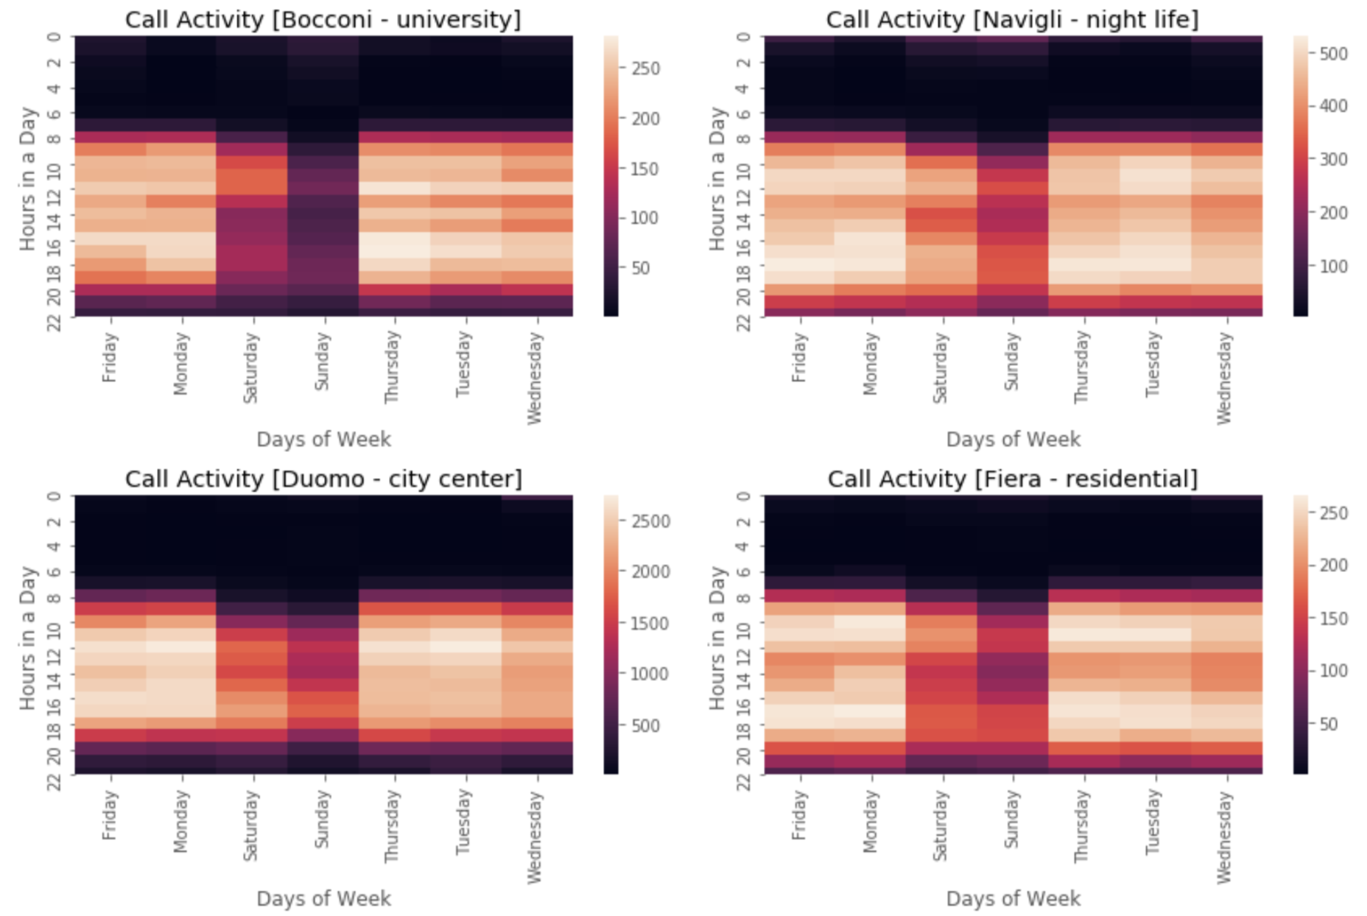

*Fig 12: Heat map of hourly Call activity of the four grids*

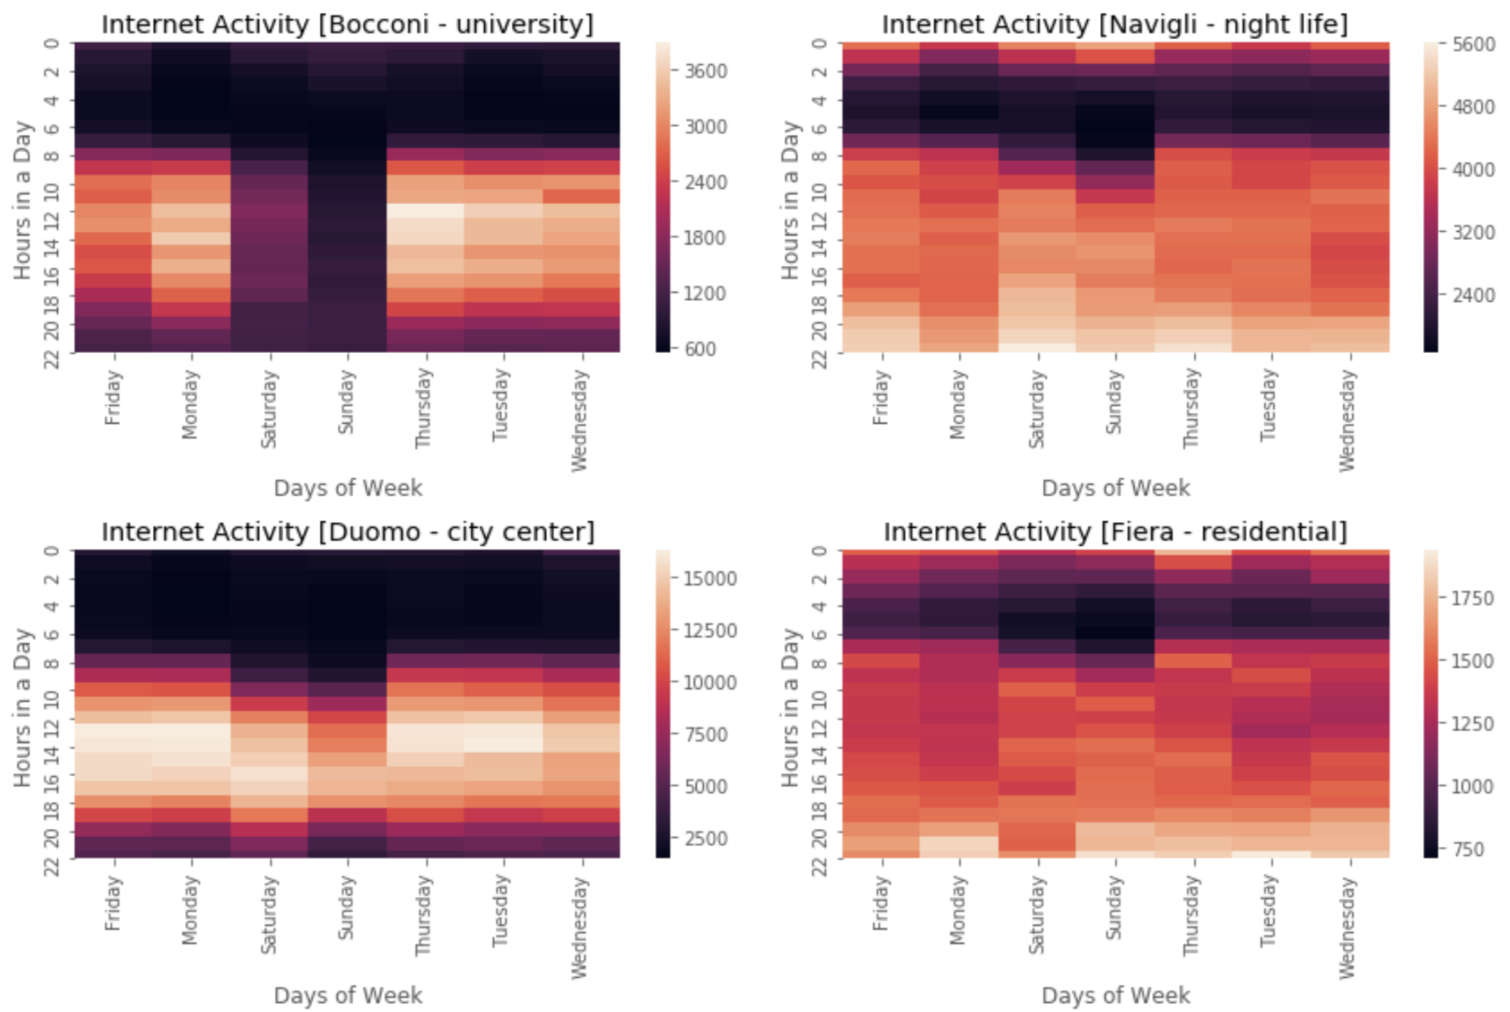

*Fig 13: Heat map of hourly telecommunication activities of the four grids*

Heat maps shows significant differences in behavior of the four grids,

##### SMS Activity:

* In general, there is less SMS activities during the weekends (Saturday & Sunday).
* Navigli, night life region shows SMS activities until 2 am in the night on weekend.
* Fiera & Navigli regions are very active from 7am till 10pm on all days.
* Duomo, city center has very less SMS activity from 10pm until 7am in the morning on weekdays and 9 am on weekends.
* Bocconi, university shows less SMS activity compared to others.
* Navigli, Duomo & Fiera shows a sudden bright region on Wednesday 12am, this must be due to New Eve falling on Tuesday.

##### Call Activity:

* Call activity has similar pattern as SMS, but lesser volumes.
* Surprisingly, there is no significant call activity on New Year eve. This shows how people are more connected via SMS and internet these days. Another possibility is that calls may have been made via internet.

##### Internet:

* Navigli & Fiera has internet activities almost all through the night. Even Bocconi, university shows some sparse activity after midnight on weekends.
* Duomo, city center although has the highest internet volumes, shows a steady pattern for all activities, 8am – 10pm on weekdays and 10am to 10pm on weekends.

## CITATIONS

* [Barlacchi, G. *et al.* A multi-source dataset of urban life in the city of Milan and the Province of Trentino. *Sci. Data*2:150055 doi: 10.1038/sdata.2015.55 (2015).](https://www.nature.com/articles/sdata201555)
* Telecom Italia, 2015, "Telecommunications - SMS, Call, Internet - MI", <https://doi.org/10.7910/DVN/EGZHFV>, Harvard Dataverse, V1
* Telecom Italia, 2015, "Milano Grid", <https://doi.org/10.7910/DVN/QJWLFU>, Harvard Dataverse, V1